Top 5 Strategies for Conducting Effective Graduate Research
Donna Ziegenfuss | 801-585-0542 | donna.ziegenfuss@utah.edu
One-Stop Marriott Library Online Resource
Strategy 1: Start Broad with Google Scholar and Usearch - Set Up Google Scholar to Link to Marriott Library Resources (http://scholar.google.com)
Scholar has the ease of Google but limits a search to more scholarly resources. It can be linked to the library databases so that you can discover resources we have at the U of U library directly from within Google Scholar while also discovering government reports, documents from Europe, Asia and Australia as well. To check to see if a journal is peer reviewed enter the name in UlrichsWeb http://ulrichsweb.serialssolutions.com.ezproxy.lib.utah.edu/ (black icon is evidence of referred/peer reviewed) – only 4 licenses can be used at one time – and you must be authenticated to the library to useTo link Google Scholar to our Marriott Library resources, to EndNote and to your own Library:
- Click on the Settings link (wheel icon) at the top of the page.
- Click on Library Links on the left navigation and type University of Utah to the search box and search, then select the Get it at the UU option, and click save Button. These settings will stay on your computer until you clean out your cache. Now you will see the Get at the UU link on the right side of the source if Utah has that in any of our databases.
- When in Search Results (first item on the left navigation menu) if you want to use a citation manager, Select EndNote for the Show Links to Import Citations list under Bibliography Manager. Now the Import to Endnote Link will appear under each source
- After you search you will see a new left hand navigation menu appear.
  - You can limit by year
  - You can click the save link and make a list of sources in own library if logged into Google
  - Sort by date or relevance
  - Include citations or patents or not by using the check box
- Now do a search using keywords to find scholarly articles. You will see under the search item listing, cited by #, related articles these may also be possible articles to check out.. Take note of journal names, keywords, author names, you can limit by those to search later
- The Get it at the UU link on the right goes directly into the Marriott Library Usearch Catalog.
Google Scholar Tip:
When having trouble finding full text, go out to Google Scholar and search the title to see if the article is available somewhere else. If not then:
- Search by the author and see if the paper was presented somewhere else or if there is a pre-print available
- Click on the Cited By or Related Articles links in Google Scholar to see other articles of interest related to the paper you are looking for
- Order the article through Interlibrary Loan

The main search field on the library homepage is a great searching broad tool. It will return sources such as books (both print and e-books), electronic or digital resources such as government docs, videos and DVDs. BUT it will not search all of our research databases – see strategy #3 to do that.
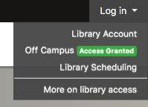
Strategy 2: Then Dig Even Deeper into Specific Library Databases Organized by Discipline for Scholarly Articles: Click on the Research Databases tab.
- Search Databases by Subject (discipline specific topics)
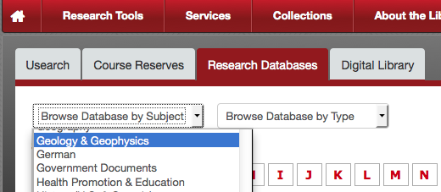
- Search Databases by Type. This is especially useful if searching for data repositories, databases containing statistical data, or newspapers.
- You can also search directly in the online journal by issue, volume number, and year by clicking on the Online Journal Link on the Library homepage (put in the name of the journal and then click the name to see all of the issues together. If the journal name does not appear in the list, then we do not have the journal and you can order through interlibrary loan
- Use Digital Dissertations & Theses Global Click on “D” for Dissertations to find international masters these and doctoral dissertations and Mine IT! – a good broad starting point
  - Look at the literature review chapter
  - Look at references and Journals cited for leads to other resources
Research Database Tip:
- Sometimes it looks like we have the article in several databases, if one link does not work, try another one of the database links
- If it looks like the link is broken (and that is possible we currently are updating our backend library catalog so there could be an error) report the error by submitting an e-ticket by clicking on the Email link that is part of the Ask the Library support box
- If I can’t find the article through using Research Databases or Online Journals I always check Google Scholar for the title before filling out an Interlibrary Loan form
- Set up journal alerts so you hear about new articles being published on your topic and keep current in your discipline at the database & journal level http://campusguides.lib.utah.edu/content.php?pid=114031
Search Databases by Subject (pull down list by subject to select your discipline)
- For education specific databases: Go to “E” under Research Databases and select EBSCOhost Databases. Then check the boxes for these sub-databases and click continue so that you can search all of them at once:
    - Academic Search Ultimate
    - APA PsychARTICLES
    - APA PsychINFO
    - Education full text
    - ERIC
    - Humanities and Social Sciences
    - Professional Development Collection
    - Psychology and Behavioral Sciences Collection
- For Special Education topics you can also include:
      - CINAHL Complete (nursing)
      - Legal Collection
      - Medline Complete
- For Diversity and Women’s Topics you can add:
      - Family and Society Studies worldwide
      - Chicano Database
      - Women’s Studies International
  - EBSCOHost Databases – good selection of general databases
  - Web of Science or Science Direct – good science databases
  - JStor or Project MUSE are 2 additional databases
- Education Subject Guides contain additional links to Educational Statistics sites, teacher and professional education organizations, recommended books and databases under the topic of education
  - Main Education Subject Guide: http://campusguides.lib.utah.edu/c.php?g=160261&p=1049626
  - Links to Education Department Library Guides:
    - Education, Leadership, and Policy
    - Education Culture and Society
    - Student Affairs
    - Educational Psychology
    - Special Education
    - Urban Institute for Teacher Education (UITE)
- If you find online journals that are particularly relevant to your topics, you can also search directly in the online journal by issue, volume number, and year by clicking on the Online Journal Link on the Library homepage (put in the name of the journal and then click the name to see all of the issues together. If the journal name does not appear in the list, then we do not have the journal and you can order through interlibrary loan
- Use Digital Dissertations & Theses Global Click on “P” for Proquest Dissertations and Master Theses to find international masters these and doctoral dissertations and Mine IT! – a good broad starting point
  - Look at the literature review chapter
  - Look at references and Journals cited for leads to other resources
  - Not a scholarly source

Strategy 3. “Mine” Good Articles & Resources … Be an Efficient Researcher
Mine Databases and Articles - Expose the potential of one mega database with many sub-databases to search several discipline specific databases all at once
- Go to EBSCOhost databases in “E” in the research database.
- Check the boxes to select databases to search and you can search them all at once. (Ex. Academic Search Ultimate, Education Full Text, Medline, Legal Collections, Family & Society Studies Worldwide, Humanities & Social Sciences Index Retrospective, PsychArticles, PsychInfo, and any other database that looks interesting.
- Look at the keywords on the abstract page for new search term ideas
- Look at the article reference list, copy the titles of other good articles and paste that into Google Scholar to see if we have the article. If you find a book in the reference list that looks promising, copy the title and paste into USearch and look to see if we have the book
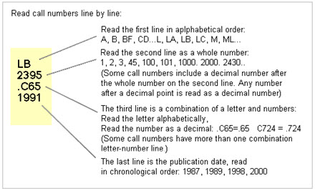
Mine the Library Catalog to find books, government documents and other goodies (you will find some articles here but not all articles) – which also has an advanced search, if you click on the advanced search option you do not have to type in AND, OR, NOT – it is already there for you to just add keywords
- We have 3 types of books in the catalog:
- 1. Print Books are available in the stacks on level 1 and 2.
  - Categorized by Library of Congress call numbers (ex to the right: LB – educational theory and practice.)
  - If we have a print copy click on the title to see the location and more information about the book
- 2. Online E-books will have a link to open the book directly
  - You can read online and download SOME chapters (but limited on # of pages – varies by publisher) but cannot download the whole book without a proprietary viewer
  - Advantage is you can search keywords!
- 3. ARC Books – are books in our automatic retrieval system and you have to order them through the catalog by logging in and requesting the book and then picking them up at the reserve desk on the 2nd floor – takes about 15-20 minutes
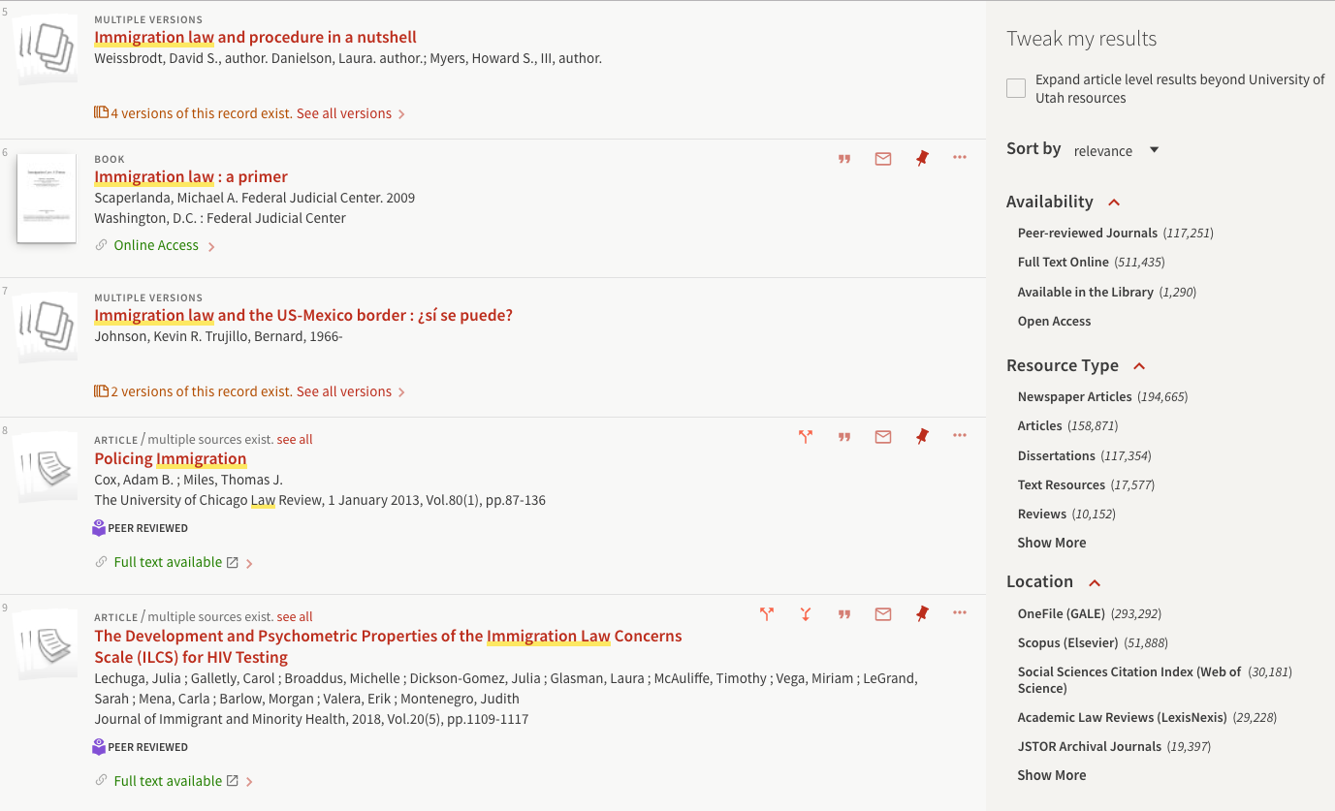
Mine the “Faceted Search” Menus -
Databases have a menu (in our catalog on the right side) where you can set filters to help narrow down your search. You can limit by:
- Peer reviewed journals only
- date
- location
- resource type
- author
- etc.

Strategy 4: Develop a Research Toolbox & Use Free Tools to Be a More Efficient Researcher!
- Use a Tool to help you Create and Manage Citations
- Endnote Basic will allow you to create AND save citations and export in any format but you must be on campus to set up the account the first time, then you can use it anywhere after that since it is a web-based tool)
- Go the Research databases Tab, Select “E” for EndNote Basic and set up an account.
- You can use EndNote from Google Scholar, the Library Usearch catalog and Databases.
  - Google Scholar – need to export to EndNote, it will save a file to your computer then you import it into EndNote
  - You can save directly for the main reference list in USearch
  - Look for the Export buttons in databases and save as either an endnote or Refman RIS file to import into Endnote (2 ways to import to EndNote – directly from Usearch a 2 step process from other databases and Scholar
  - EBSCO has an endnote export but is not working
  - Subject Guide to help you use EndNote Basic by Lorelei Rutledge http://campusguides.lib.utah.edu/content.php?pid=619452
Guide by Mary MacFarland: http://campusguides.lib.utah.edu/c.php?g=448524&p=3061147
- Other Citation Management Tools
  - Mendeley - Subject guide to help you get set up and running http://campusguides.lib.utah.edu/c.php?g=160664&p=1052815
  - Zotero - Subject guide to help you get set up and running http://campusguides.lib.utah.edu/zotero/home
- You can also cite from within databases by clicking on the cite button, most databases have them (We will go over that as we go through databases)
- APA Formatting
- APA 7th edition tutorial (Links to an external site.) and APA manual instructional aids
2. Save PDFs to BOX! http://box.utah.edu
- You login with your unid and password
- Can set up folders for different projects and upload files to your folder you can access from anywhere
- Can share a link to a file or folder
Strategy 5: Be Proactive … Ask Questions, Scope Out Other Resources!!!
Librarians are your friends: Each discipline has an assigned librarian liaison and there are others in the library to help
- The Marriott Library also provides Statistical Support through a Library Stats TA. If you are working on statistical data as part of your research you can make an appointment for a consultation. Email mlib-statistics@lists.utah.edu to set up an appointment.
- There is also a Special Web Page for Graduate Student Resources: http://lib.utah.edu/services/education/gradstudents.php
- You can email and set up one-on-one research consultation or contact them about resources or using citation management software. To get the list of Library Liaisons with email links: http://www.lib.utah.edu/collections/subject-specialists.php; along with a list of library departments http://www.lib.utah.edu/info/departments.php .
- NOT OPEN DURING COVID - There is also a Graduate Student Reading Room that only graduate students can get access to. Stop at the Security desk on the first floor of the Library to fill out a form and they will add access to the room on your U ID card – you just swipe at the door, 1180 to get in.
- The Graduate Writing Center https://writingcenter.utah.edu/grad-student-services.php which is inside the Graduate Reading Room and you can set up an appointment (note: you will need to get your ID updated so you can get in for your appointment).
- You can make an appointment for e-writing support at: https://writingcenter.utah.edu/graduate-services/e-tutoring.php

Don’t Forget About Other Library Resources
- Subject Guides are set up by the library liaisons and contain resources for every discipline. You can find the guide on the library home page navigation menu or here http://campusguides.lib.utah.edu/index.php - search by your discipline.
There are also how-to guides on things like:
  - writing a literature review http://campusguides.lib.utah.edu/content.php?pid=94096
  - social science data guide http://campusguides.lib.utah.edu/ssdata
  - Other graduate level workshop materials in Canvas: https://utah.instructure.com/courses/353729
- The library offers workshops each semester, you can find the list under workshops on the library homepage or here at: https://eventregistration.tools.lib.utah.edu
- Can’t find articles or books in the library you need for your research? You have several options to help you get the research materials you need:
- Interlibrary Loan (ILL) http://lib.utah.edu/services/interlibrary-loan.php (login with your Unid and password to request articles, books, etc)
- Suggest a Purchase http://www.lib.utah.edu/services/suggest-a-purchase.php
If you think a book you need would be a valuable resource in our collection you can suggest thelibrary purchase it for you
- Books requested through online searching as well as Interlibrary Loan can be picked up on the first floor at the security desk

- We also have other resources that might help you with your research:
  - A Digital and Multimedia Collection http://www.lib.utah.edu/collections/digital-library.php
  - Special Collections http://www.lib.utah.edu/collections/special-collections/index.php
  - Government Documents Collection with experts on helping you find documents http://www.lib.utah.edu/collections/gov-docs.php

- There is more than ONE Library. The University of Utah has the Marriott Library AND ALSO a Law, a Music, and a Health Sciences Library. Each Library has a phone and email contact info on their homepage and Eccles and the Marriott have a virtual chat option as well. Look for the “Ask the Library” or “Ask a Question” logos on the Library webpages. In addition to the Marriott Library (http://lib.utah.edu ):
- Need legal topic or education law and policy information you can request law research assistance at the S. J. Quinney College of Law Library website
http://www.law.utah.edu/library/
- If you are searching a medical or health professions topic; don’t forget we have a library for that … Spencer S. Eccles Health Sciences Library (right next to the hospital/Medical School; who can help you navigate complex databases like PubMed
http://library.med.utah.edu/index.php

Post COVID-19 NOTE:
- The Reserve Desk and scanners will be on the 3rd floor

