Top 5 Strategies for Effective Research
Donna Ziegenfuss | 801-585-0542 | donna.ziegenfuss@utah.edu
https://utah.instructure.com/courses/353729

Strategy 1: Go Broad first.
Set Up Google Scholar to Link to Marriott Library Resources (http://scholar.google.com)
Scholar has the ease of Google but limits a search to more scholarly resources. NOTE: Not all are peer reviewed and includes conferences, dissertations, etc.!! To check to see if a journal is peer reviewed enter the name in UlrichsWeb http://ulrichsweb.serialssolutions.com.ezproxy.lib.utah.edu/ (black icon is evidence of referred/peer reviewed) – only 4 licenses can be used at one time – and you must be authenticated to the library to use
- Can link to the library databases so that you can discover resources we have at the Marriott directly from within Google Scholar
- More access to international education literature
- Use it to find references you are looking for (copy and past title in the search)
- Click on the Settings link (wheel) at the top of the page.
- When in Search Results (first item on the left navigation menu) Select EndNote for the Show Links to Import Citations list under Bibliography Manager. Now the Import to Endnote Link will appear under each source.
- To set up your home computer: Click on Library Links on the left navigation and type University of Utah (when off campus) to the search box and search, then select the Get it at the UU option, and click save Button. These settings will stay on your computer until you clean out your cache. Now you will see the Get at the UU link on the right side of the source if Utah has that in any of our databases.
- After you search you will see a new left-hand navigation menu appear.
  - You can limit by year, sort by date or relevance
  - Set up an alert for your search
- Now do a search using keywords to find scholarly articles. You will see under the search item listing, cited by #, related articles these may also be possible articles to check out. Take note of journal names, keywords, author names, you can limit by those to search later
- The Get it at the UU link on the right goes directly into the Marriott Library Usearch Catalog.
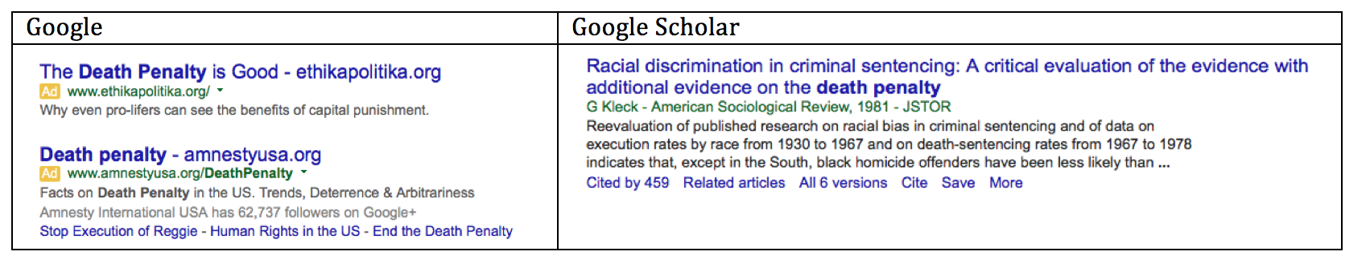
Google Scholar Tip:
When having trouble finding full text, go out to Google Scholar and search the title to see if the article is available somewhere else. If not then:
- Search by the author and see if the paper was presented somewhere else or if there is a pre-print available - Google Scholar Profiles if author name is underlined
- Use multiple keywords/search terms to narrow down
  - Use AND, OR, NOT to separate the words
  - Keep experimenting, it may take a while till you find the right words
- Click on the Cited By or Related Articles links in Google Scholar to see other articles of interest related to the paper you are looking for
- If not available order the article through Interlibrary Loan http://lib.utah.edu/services/interlibrary-loan.php

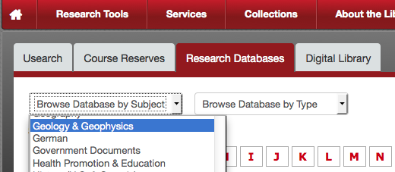
Strategy 2: Then Dig Even Deeper into Specific Library Databases Organized by Discipline for Scholarly Articles: Click on the Research Databases tab.
- Search Databases by Subject (discipline specific topics – education, psychology, sociology
- Search Databases by Type. This is especially useful if searching for data repositories, databases containing statistical data, or newspapers.
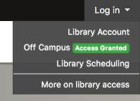
- Once in the database, use Advanced Search – better for searching
- If off campus, log into the library first to authenticate to the U of U by clicking on the Log In arrow on the library homepage http://lib.utah.edu and then log in with your UNID (if you don’t you will not be able to download full text articles) – When logged in, it will say access granted like in the graphic to the right.
- You can also search directly in the online journal by issue, volume number, and year by clicking on the Online Journal Link on the Library homepage under Quick Links (put in the name of the journal and then click the name to see all of the issues together. If the journal name does not appear in the list, then we do not have the journal and you can order it through interlibrary loan for free: http://www.lib.utah.edu/services/interlibrary-loan.php
- EBSCOhost

- Use Digital Dissertations & Theses Global Click on “P” for Proquest Dissertations to find international masters these and doctoral dissertations and Mine IT! – a good broad starting point
  - Look at the introduction and literature review chapter
  - Look at references and what journals are cited for leads to other resources
Research Database Tip:
- Sometimes it looks like we have the article in several databases, if one link does not work, try another one of the database links
- Read the abstract before downloading articles – it will save you time from wading through articles
- If it looks like the link is broken (and that is possible this happens) report the error by submitting an e-ticket by clicking on the Email link that is part of the Ask the Library support box
- If I can’t find the article through using Research Databases or Online Journals I always check Google Scholar for the title before filling out an Interlibrary Loan form – sometimes it is somewhere else
- Set up Google Scholar alerts so you hear about new articles being published on your topic and keep current in your discipline at the database & journal level http://campusguides.lib.utah.edu/content.php?pid=114031

Strategy 3. “Mine” Good Articles & Resources … Be an Efficient Researcher
Mine Databases and Articles - Expose the potential of one mega database with many sub-databases to search several discipline specific databases all at once
- Go to EBSCOhost databases in “E” in the research database.
- Check the boxes to select databases to search and you can search them all at once. (Ex. Academic Search Ultimate, Education Full Text, Medline, Legal Collections, Family & Society Studies Worldwide, Humanities & Social Sciences Index Retrospective, PsychArticles, PsychInfo, and any other database that looks interesting.
- Look at the keywords on the abstract page for new search term ideas
- Look at the article reference list, copy the titles of other good articles and paste that into Google Scholar to see if we have the article. If you find a book in the reference list that looks promising, copy the title and paste into USearch and look to see if we have the book
Mine the Library Catalog to find books, government documents and other goodies (you will find some articles here but not all articles) – which also has an advanced search, if you click on the advanced search option you do not have to type in AND, OR, NOT – it is already there for you to just add keywords
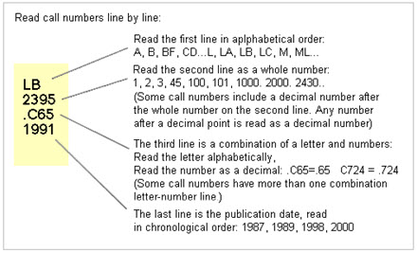
- We have 3 types of books in the catalog:
- 1. Print Books are available in the stacks on level 1 and 2.
  - Categorized by Library of Congress call numbers (ex to the right: LB – educational theory and practice.)
  - If we have a print copy click on the title to see the location and more information about the book
- 2. Online E-books will have a link to open the book directly
  - You can read online and download SOME chapters (but limited on # of pages – varies by publisher) but cannot download the whole book without a proprietary viewer
  - Advantage is you can search keywords!
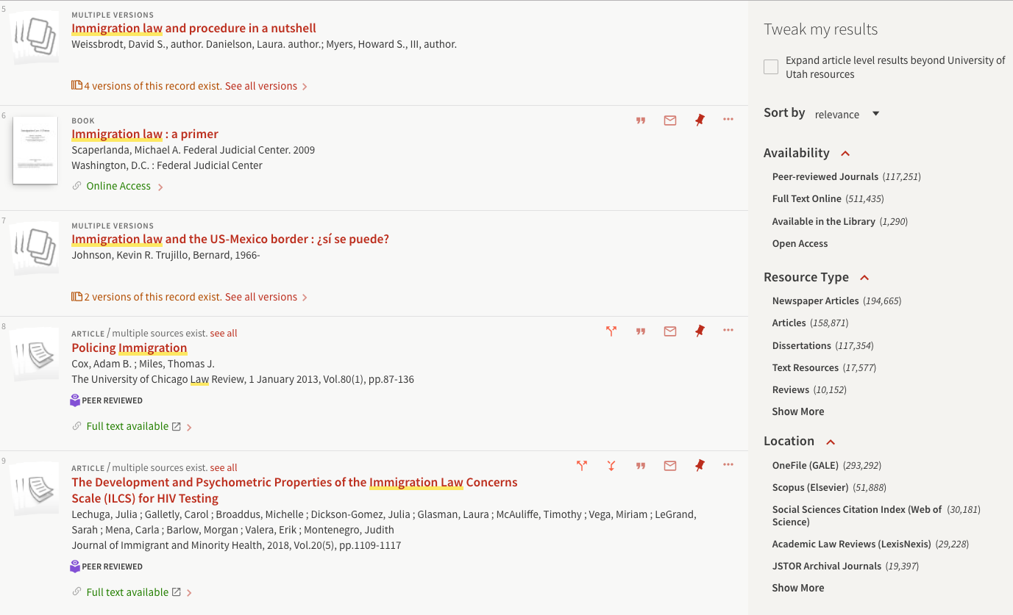
- 3. ARC Books – are books in our automatic retrieval system and you have to order them through the catalog by logging in and requesting the book and then picking them up at the reserve desk on the 2nd floor – takes about 15-20 minutes

Mine the “Faceted Search” Menus -
Databases have a menu (in our catalog on the right side) where you can set filters to help narrow down your search. You can limit by:
- Peer reviewed journals only
- date
- location
- resource type
- author
- etc.

Strategy 4: Use Free Tools to Be a More Efficient Researcher!
Free EndNote Basic Account for Managing Citations (you must be on campus to set up the account but you can use it anywhere after that since it is a web-based tool)
Go the Research Databases Tab, Select “E” for EndNote Basic click on Don't have an account? Set Up an account (use your U of U email – unid@mail.utah.edu)
- You can use EndNote from Google Scholar, the Library Usearch catalog and other Databases.
- 2 methods: direct export and download
  - Learn how to use other citation tools:
    - Endnote: http://campusguides.lib.utah.edu/c.php?g=160850&p=1051438
    - Zotero: http://campusguides.lib.utah.edu/zotero/home
    - Mendeley: http://campusguides.lib.utah.edu/c.php?g=160664&p=1052815
  - Direct Method:
    - Library Catalog (click on title for detail, then click export
    - Any EBSCOhost database (ERIC, Education Full text, Psychology Journals etc.)
    - Web of Science, APA e-books
  - Download Method:
    - Google Scholar – you need to export to EndNote, it will save a file to your computer then you import it into EndNote
    - JStor, Scopus,
    - Always look for the Export buttons in databases and save as either an endnote (.enw) or Refman (.ris) file to import into Endnote
Save PDFs to BOX! http://box.utah.edu (a Terabyte of storage!!)
- You login with your unid and password, set up folders for different projects, and upload files to your folder (single or in bulk); you can access from anywhere
- Can share a link to a file or folder with peers or instructors
- Tag files to find easier, think about your naming convention
- If you prefer Google Drive – the U of U has Google Cloud! http://gcloud.utah.edu/
Use SUBJECT GUIDES for a QuickStarter
- Use Subject Guides (see the quick link on the library homepage – left bottom) that are Discipline Specific to find a goldmine of resources can search the subject guides from this screen
- Subject Guides are set up by the library liaisons and contain resources for every discipline. You can find the guide education topics here:
  - Education Library Guide: http://campusguides.lib.utah.edu/c.php?g=160261&p=1050092
  - Library Workshops: Writing a literature Review: https://utah.instructure.com/courses/353729/pages/details-literature-review
  - Writing Annotated Bibliographies: http://campusguides.lib.utah.edu/c.php?g=160354&p=1052148
- Use other tools like Evernote, OneNote, an excel spreadsheet to track what keywords you have searched and where you have searched. Use concept mapping to brainstorm keywords and connections

Strategy 5: Be Proactive … Ask Questions, Scope Out Other Resources!!!
- Interlibrary Loan (ILL) http://lib.utah.edu/services/interlibrary-loan.php (login with your Unid and password to request articles, books, etc)
- Suggest a Purchase http://www.lib.utah.edu/services/suggest-a-purchase.php
If you think a book you need would be a valuable resource in our collection you can suggest the library purchase it for you
- Use the chat and email options under ask us on the library homepage
- You can email and set up one-on-one research consultations. To get the list of Library Liaisons with email links: http://www.lib.utah.edu/collections/subject-specialists.php; along with a list of library departments http://www.lib.utah.edu/info/departments.php . I am your Education librarian! But you may have a topic related to business, or diversity, or health education and there are librarians for that!
- In addition to library guides on disciplines, we also have library guides on things like:
  - Writing a literature review http://campusguides.lib.utah.edu/content.php?pid=94096
  - Social science data guide: http://campusguides.lib.utah.edu/ssdata
  - Canvas Library resources: https://utah.instructure.com/courses/353729
  - NOTE: The Reserve Desk and scanners are now on level 3

