French 4900/6900, Spring 2015, “Le Roman de la Rose”
For most modern readers, Le Roman de la Rose is a strange book. It is a dream, written up in the form of an allegory, in which a poet falls in love with a plant, attempts to give it a kiss, is repeatedly rebuffed by strange personifications like Fear, Danger, Badmouth, Jealousy, and is aided by other strange personifications such as Delight, Fair friend, Hope, Sweet thought, etc. A tower is built to protect the rose, and the poet-lover is confronted with an endless series of obstacles until finally the tower is stormed the rose is taken. Most of this allegory echoes the themes of courtly romance, with the pursuit of the lover and all the psychological pitfalls of that pursuit converted into a kind of psychomachia (psychological battle) instead of the back and forth struggle of courtly lovers that we see in books like Lancelot and Yvain. Unlike earlier romances, this one is narrated in the first person. Also unlike earlier romances, this lover-protagonist is not a knight but the poet himself. This is a very significant shift in medieval narrative. We will discuss the language and narration of the “self” at some length. In addition to a close relation to earlier romances, the Roman is clearly and highly indebted to Ovid. We will follow up on these debts and discuss them at length, particularly the stories of Narcissus and Pygmalion. If the Roman converts the discourse of traditional romance, with its knights and ladies and its quests, into an allegory of the self, it does so with very interesting obstacles and difficulties. Remember Calogrenant’s famous line: “je suis un chevalier qui cherche ce qu’il ne peut trouver.” Our protagonist will share Calogrenant’s difficulty and have a very hard time ever obtaining the thing he most seeks. 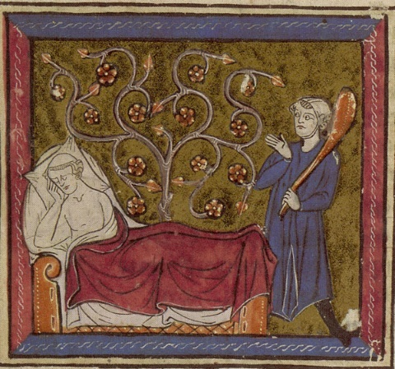
Vatican Urb Lat 376 Folio 1: lover, rose, Danger
More practically: This seminar will focus exclusively on one seminal medieval book, Le Roman de la Rose. We will read the combined version of the romance, including Guillaume de Lorris’s 4000 verse poem from ca. 1225 as well as the 15,000 verses added by Jean de Mean ca. 1280. The focus on one work will allow students to develop considerable expertise – of the text, its historical, cultural, and literary context, and of the critical tradition of interpretations of the text. Since the Roman de la Rose was one of the most copied manuscripts of the medieval period, it has a long and illustrious tradition of visual illumination. We will spend considerable time on the images with which manuscripts illustrate this poem. The critical tradition surrounding the work is almost as rich as the work itself and runs from the moralizing to the allegorical to the psychoanalytical to the post-modern. Once we have roman all figured out, we will work our way through these interpretations and attempt to contribute our own. The course will be conducted as a graduate seminar with lots of student generated discussion and a fair amount of reading. Undergraduates will be required to write two 7-10-page papers and do one presentation. Graduates will be required to write one 15-20-page paper with one presentation. Most reading and viewing materials will be made available through Canvas. You will need to purchase the following book (if you own another version, contact me to see if it will work):
Author: Guillaume de Lorris and Jean de Mean
Title: Le Roman de la Rose
Publisher: Livre de Poche, (collection) Lettres Gothiques
Isbn: 978 2 253 06079 6

